Prototype
(Creational)

This pattern involves a single class which is responsible to create an object while making sure that only single object gets created. This class provides a way to access its only object which can be accessed directly without need to instantiate the object of the class.

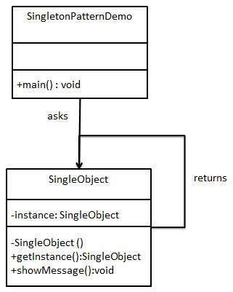

Step 1
public class SingleObject {

//create an object of SingleObject
private static SingleObject instance = new SingleObject();

//make the constructor private so that this class cannot be
//instantiated
private SingleObject(){}

//Get the only object available
public static SingleObject getInstance(){
return instance;
}

public void showMessage(){
System.out.println("Hello World!");
}
}

Step 2
public class SingleObject {

//create an object of SingleObject
private static SingleObject instance = new SingleObject();

//make the constructor private so that this class cannot be
//instantiated
private SingleObject(){}

//Get the only object available
public static SingleObject getInstance(){
return instance;
}

public void showMessage(){
System.out.println("Hello World!");
}
}

Step 3 (output)
Hello World!

Eager initialization
The upper approach

Lazy Initialization

public class SingleObject {

private static SingleObject instance;

//make the constructor private so that this class cannot be
//instantiated
private SingleObject(){}

//Get the only object available
public static SingleObject getInstance(){
if (instance == null) {
instance = new SingleObject();
}
return instance;
}

public void showMessage(){
System.out.println("Hello World!");
}
}

